Arduino Based Digital Temperature Monitoring System
This document explains the complete working, components, and connections of an Arduino-based digital temperature monitoring system using a temperature sensor, LCD display, LEDs, and potentiometer.

1. Objective
The objective of this project is to measure ambient temperature using a temperature sensor, process the data using an Arduino UNO, and display the temperature in degrees Celsius on a 16x2 LCD display. Visual indication using LEDs is also provided.

2. Components Used
- Arduino UNO
- Temperature Sensor (TMP36/LM35)
- 16x2 LCD Display
- 10kΩ Potentiometer
- Breadboard
- LEDs (Red and Green)
- Resistors
- Jumper Wires
- USB Power Supply

3. Circuit Description
The Arduino UNO acts as the central controller. The temperature sensor is connected to the analog input pin of the Arduino. The LCD display is interfaced in 4-bit mode to reduce the number of I/O pins used. A potentiometer is connected to adjust the LCD contrast. LEDs are used as indicators based on temperature levels.

4. Working Principle
The temperature sensor produces an analog voltage proportional to the ambient temperature. This voltage is read by the Arduino's ADC and converted into a digital value. The Arduino processes this value and calculates the temperature in degrees Celsius. The result is displayed on the LCD. Based on predefined temperature thresholds, LEDs are switched ON or OFF.

5. LCD Display Output
The LCD shows a message such as 'Temperature in C' followed by the real-time temperature value. The display updates continuously as the temperature changes.

6. Advantages
- Real-time temperature monitoring
- Low cost and easy to implement
- High accuracy
- Expandable for IoT applications

7. Applications

A digital thermometer is used to verify a smart temperature transmitter under flowing conditions and a successful calibration of the smart temperature transmitter

8. Circuit Diagram
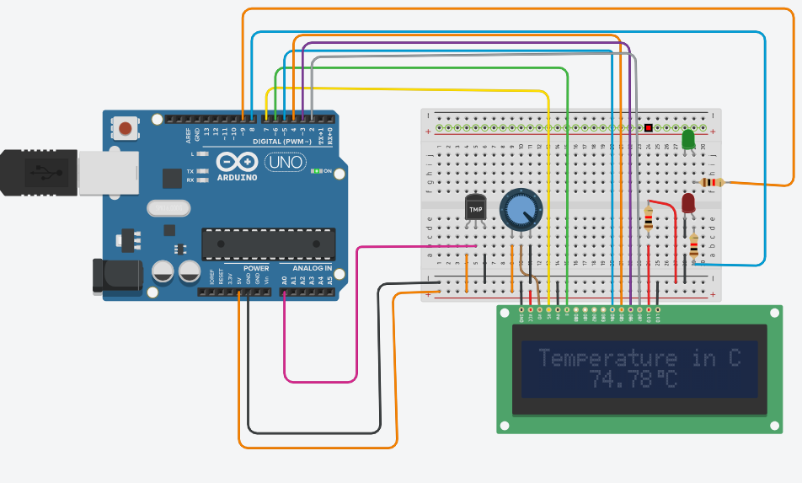
9.PIN GIAGRAM
LCD Pin | Name | Connects To
1 | VSS | GND
2 | VDD | 5V
3 | VO | Middle pin of potentiometer
4 | RS | Arduino D12
5 | RW | GND
6 | E | Arduino D11
11 | D4 | Arduino D5
12 | D5 | Arduino D4
13 | D6 | Arduino D3
14 | D7 | Arduino D2
15 | A (LED +) | 5V (through 220Ω resistor)
16 | K (LED –) | GND

Potentiometer (LCD Contrast)
Pot Pin | Connection
Left | GND
Middle | LCD Pin 3 (VO)
Right | 5V

LEDs

Green LED
LED Pin | Connection
Anode (+) | Arduino D8 (via 220Ω resistor)
Cathode (–) | GND

Red LED
LED Pin | Connection
Anode (+) | Arduino D9 (via 220Ω resistor)
Cathode (–) | GND

Arduino Power Connections
Arduino Pin | Connected To
5V | Breadboard + rail
GND | Breadboard – rail

LCD Library Pin Declaration (IMPORTANT)
Use this in your Arduino code:
#include <LiquidCrystal.h>

LiquidCrystal lcd(12, 11, 5, 4, 3, 2);

void setup() {
lcd.begin(16, 2);
lcd.print("Hello!");
}

void loop() {
}

10.block diagram

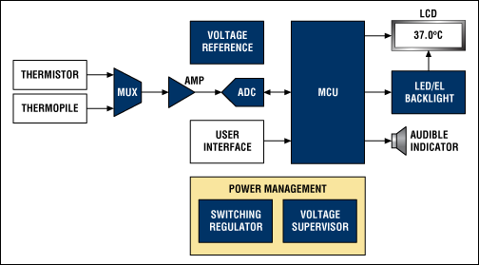

11. parts of thermometer
temperature sensor, signal conditioning circuitry, analog-to-digital converter, microcontroller/display driver, dA digital thermometer is used to verify a smart temperature transmitter under flowing conditions and a successful calibration of the smart temperature transmitterisplay, and power supply. Additional components improve linearity, isolation, accuracy, etc.
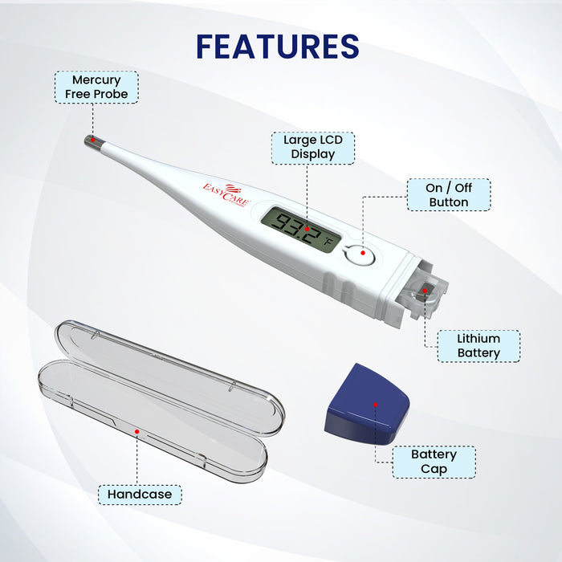

12.observations
A digital thermometer is used to verify a sA digital thermometer is used to verify a smart temperature transmitter under flowing conditions and a successful calibration of the smart temperature transmittermart temperature transmitter under flowing conditions and a successful calibration of the smart temperature transmitter

Linkl
https://www.tinkercad.com/things/jMqPALWbH32-epic-turing-maimu?sharecode=jUhued9d8OGcqUQyX69Fqbg2T0oQXESxwcuIYFk-nbQ

